Provident Fund Trust Module
Main Database
Banks

Accounts
GL Accounts

FSF Accounts

Banks

Opening Balance

FN-Statement Policy

Main Transactions
Receipt Vouchers
(Cash & Bank)
Payment Vouchers
(Cash & Bank)

Journal Vouchers
Member’s Payment

Member’s Settlement

Table of Contents

Requirements Analysis
Systems Characteristics
Integration with Other Modules
User Pre-Requisites
Getting Started
Setups
- Financial Account File ......................................................................................................
- General Account File ……………………………………………………………………………………………………
- Opening Balance File …………………………………………………………………………………………………..
- FN-Statement Policy File ……………………………………………………………………………………………..
- Bank File ……………………………………………………………………………………………………………………
- Document Serial File ……………………………………………………………………………………………………
Transactions
- Cash Receipt Voucher: Recording Receipts in Cash ………………………………………………………..
- Cash Payment Voucher: Paying in Cash ………………………………………………………………………..
- Bank Receipt Voucher: Recording Receipts through Checks …………………………………………….
- Bank Payment Voucher: Paying through Checks ……………………………………………………………
- Journal Voucher: Recording of …………………………………………………………………………………….
- Member’s Payment: Recording of …………………………………………………………………………………
- Member’s Settlement: Recording of ……………………………………………………………………………..

Reports
- Financial Statement Heads …………………………………………………………………………………………
- Chart of Accounts …………………………………………………………………………………………………. …
- Opening Balance ………………………………………………………………………………………………………..
- FN-Statement Policy ………………………………………………………………………………………………….
- Member Listing ………………………………………………………………………………………………………….
- Bank Listing ……………………………………………………………………………………………………………..
- Document Serial Listing ……………………………………………………………………………………………..
- Transaction Logs ………………………………………………………………………………………………………
- Voucher Listing …………………………………………………………………………………………………………
- Financial Books …………………………………………………………………………………………………………
- Trial Balance …………………………………………………………………………………………………………….
- Ledger …………………………………………………………………………………………………………………….
- Financial Statement …………………………………………………………………………………………………..
- PF Register ………………………………………………………………………………………………………………
- PF Profit …………………………………………………………………………………………………………………..
- PF Mark Up ………………………………………………………………………………………………………………
- PF Balance ……………………………………………………………………………………………………………….
- Zakat Deduction ………………………………………………………………………………………………………..
Utility Tools
- Auditing Process ……………………………………………………………………………………………………….
- Posting Process …………………………………………………………………………………………………………
- Un-Posting Process…………………………………………………………………………………………………….
- JV Generation …………………………………………………………………………………………………………..
- JV Deletion ………………………………………………………………………………………………………………

Requirements Analysis
Systems Characteristics
Integration with Other Modules

Provident Fund Trust Module is linked with the following FCL modules:

PF PY

HR
Dependency Diagram
- Human Resource -HR
- Payroll -PY

Relationship with HR Module

- If Provident Fund Trust Module uses HR for getting list of FCL employees and their current status; i.e. whether they have LEFT the job or are still on job
- For all transactions, the members list available for selection (in either Quick Search Window or transaction combos) brings up only those members who ‘have left FCL’ OR ‘whose Date Left is not BLANK’

Relationship with Payroll Module

- In its JV Generation Process, FCL PF Module gathers all kinds of necessary information about Provident Fund Trust members employed by FCL and generates a Journal Voucher worth as per their ‘last processed payroll’.
- JV Generation Process leaves this tags the relevant members’ payroll transactions that their JV has been generated; JV Deletion Process does vice versa.

User Pre-Requisites

Getting Started

Setup
_______________________________________________________________________________

Setup files are data entry screens for the following main database entities of the Provident Fund Trust Module:

- Financial Accounts
- General Accounts
- Opening Balance
- FN-Statement Policy
- Bank
- Document Serial Nos

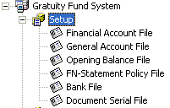 | 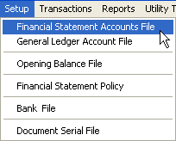

In the subsequent pages, each Setup entry is described briefly with the help of screen-shots.
Financial Accounts File
_______________________________________________________________________________

Description
A simple Code-Name data entry form for keeping record of different levels of financial statement accounts which are associated with GL Accounts with the help of Financial Statement Policy; the corresponding code-length is 2, 4, and 7, respectively.

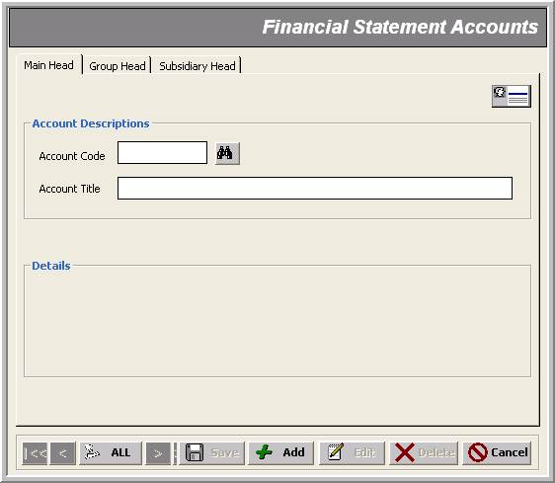
* Account Name (@³⁰)

* Main Level Code (@@)

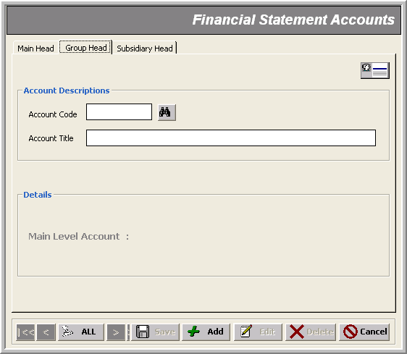
* Account Name (@³⁰)

* Group Level Code (@@@@)

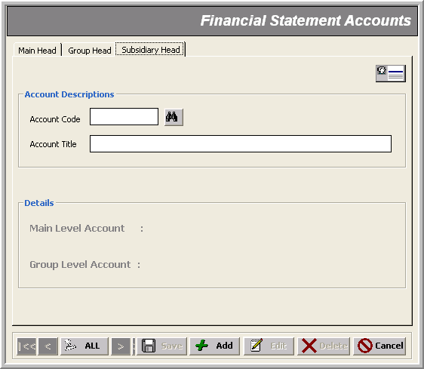
* Account Name (@³⁰)

* Subsidiary Level Code (@⁷)
General Accounts File
_______________________________________________________________________________

Description
The heart of GL module where we define four levels of accounts; namely: Group, General, Subsidiary and Sub-subsidiary; the corresponding code-length is 2, 4, 8 and 11, respectively.

Note that:
- For Financial Statement Reports, we specify which Debit/Credit Account Heads are going to be affected for a particular Financial Statement Account related change

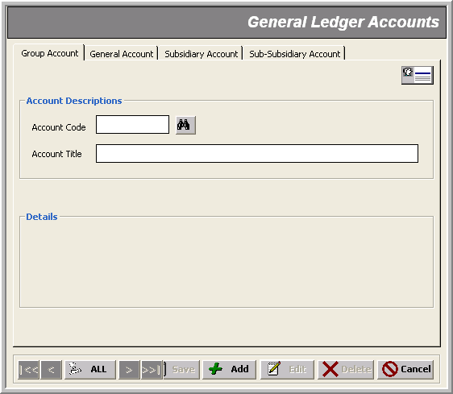
* Account Name (@³⁰)

* Group Level Code (@@)

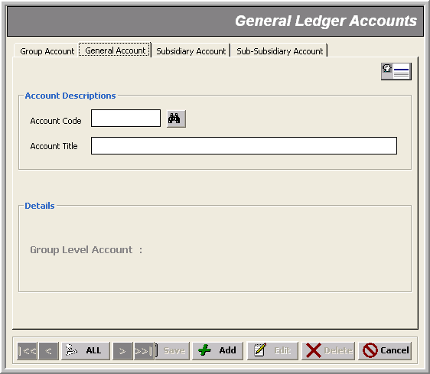
* Account Name (@³⁰)

* General Level Code (@@@@)
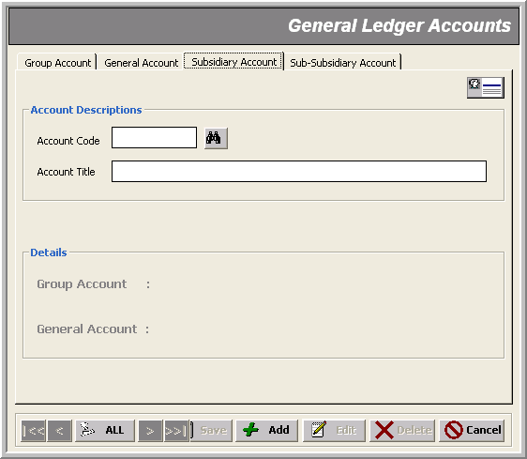
* Account Name (@³⁰)

* Subsidiary Level Code (@⁸)
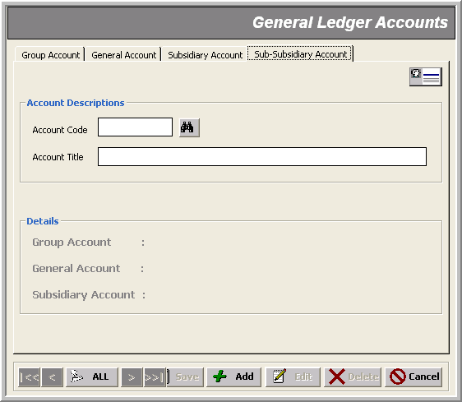
* Account Name (@³⁰)

* Sub Subsidiary Level Code (@¹¹)
Opening Balance File
_______________________________________________________________________________

Description
This form is used for entering opening balances of different members fund in a particular account head; it could be either in Debit or in Credit.

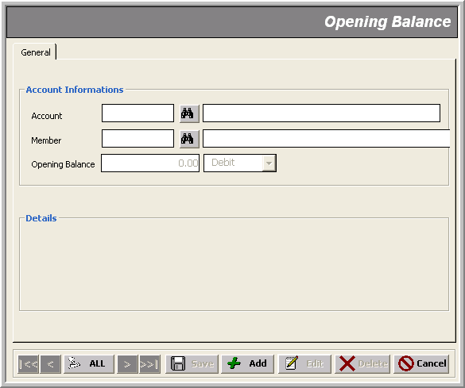
Amount in Dr or Cr

* Account Code of last Level
* FCL Employee

Note that:
- The Provident Fund related account heads are as follows:
1301 Permanent Withdrawal
1302 Refundable Withdrawal
1401 Accrued Markup on PF Loan
2101 Member’s Contribution – Graded Staff
2102 Company’s Contribution – Graded Staff
- On selecting an account other than those given above, the Member selection/input is disabled

FN Statement Policy File
_______________________________________________________________________________

Description
This form helps you relate a Financial Statement Account with the GL Accounts which are going to be affected for a Debit/Credit change in that FIN Account. Hence, the Financial Statements are maintained accordingly.

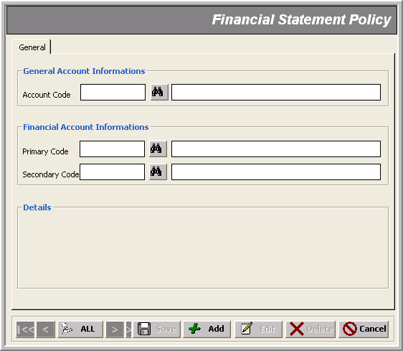
Financial Accounts Head
* GL Account of any Level

Bank File
_______________________________________________________________________________

Description
Here we specify the banks’ information that FCL deal with for its financial activities. The GL account defined by GL Code is used to record the bank related transactions.

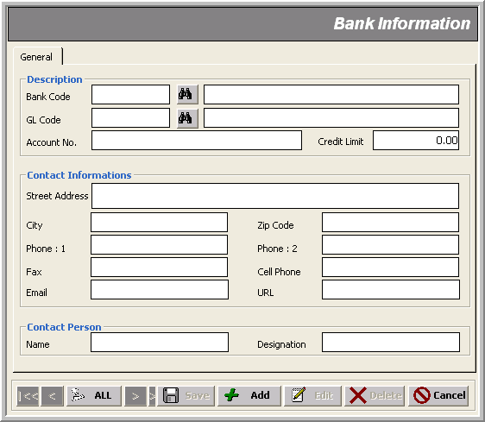
Bank Account No
* Bank Code (@@)
* Last Level GL Account
Credit Limit
Other Bank Info
Document Serial File
_______________________________________________________________________________

Description
This form is used to specify serial numbers for all kinds of transactions; the general format is ‘yymmnnnn’ where:
‘yy’ => current year
‘mm’ => current month
‘nnnn’ => actual serial showing no of transactions of this type
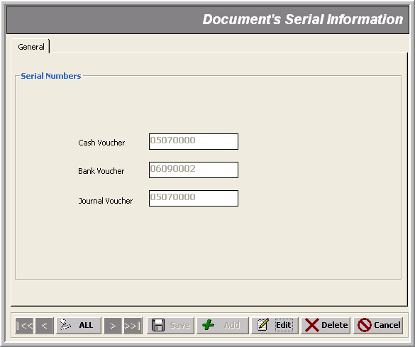
Transaction Serial No.’s
Transactions
_______________________________________________________________________________
There are nine transactions in the Provident Fund Trust financial module that can be classified into the following categories:

- Recording Receipts in Cash - Cash Receipt Voucher
- Paying in Cash - Cash Payment Voucher
- Recording Receipts through Checks - Bank Receipt Voucher
- Paying through Checks - Bank Payment Voucher
- Doing Receipts or Payments on the fly - Journal Voucher
- Recording Payments to PFT Members – Member’s Payment
- Recording Receipts from PFT Members – Member’s Settlement

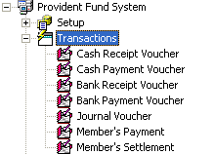 | 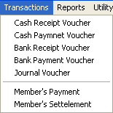

Here are the general validations during the data entry of any transaction:

Note that:
- fields marked with asterisk * in the snap-shots are mandatory
- transaction number gets generated automatically in ‘yymmnnnn’ format where:
yy => current year
mm=> current month
nnnn=> Auto generated serial no.
- transaction dates must lie within the same month as indicated by the transaction number; or else you get an error message:
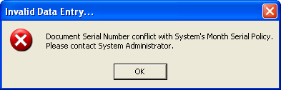
or
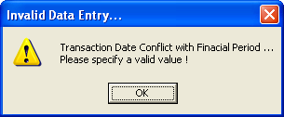
- A transaction gets LOCKED as soon it is created and can be editable only when Un-Posting Process is run by the authorized user (e.g. the administrator )
- Similarly, if the Posting Process has locked a date, transaction entry is disallowed thereon:
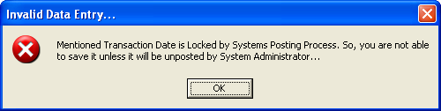
- No transaction is allowed if there is already some un-posted transactions:
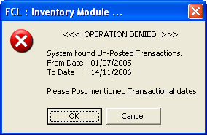
- Similarly, if Posting or Auditing process is currently in progress; the system denies any transaction entry with an alert like:
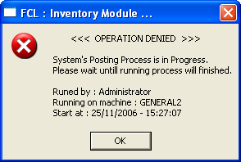
- As of date, The Provident Fund related account heads (which are pre-defined in the System’s database) are as follows:
1301 Permanent Withdrawal
1302 Refundable Withdrawal
1401 Accrued Markup on FP Loan
3107 Markup on FP Loan
2101 Member’s Contribution – Graded Staff
2102 Company’s Contribution – Graded Staff
- But these ‘pre-defined’ accounts could well be changed
- On selecting an account other than those given above, the Member selection/input is disabled; And ‘any user’ CAN make vouchers without any user specific constraint
- For all transactions, the members list available for selection (in either Quick Search Window or transaction combos) brings up members based on whether or not the current user is the administrator or a normal user:
- the normal user can find ‘only those members who belong to the current ‘fiscal year’
- the administrator can find ‘ALL the members belonging to ALL the years’
- For all the normal vouchers, the member/employee selection criteria for a normal user and an administrator is as follows:
For Normal User For Administrator
only current members all members up to date
(with ‘Date Left to be BLANK’) (with BLANK ‘Date Left’ and FILLED ‘Date Left’)

Cash/Bank Receipt Voucher _______________________________________________________________________________
Use case: Recording Receipts

Description
These forms are used to create Receipt Vouchers with the following mandatory data entry:

- Voucher No (Auto generated in ‘yymmnnnn’ format)
- Voucher Date
- Received From
- Check No (if receiving through check; mandatory in case of Bank Receipt Voucher)
- Drawn On (the bank with which the check is drawn; mandatory in case of Bank Receipt Voucher)
- On Account of
- More than one journal entry against a GL Account and member

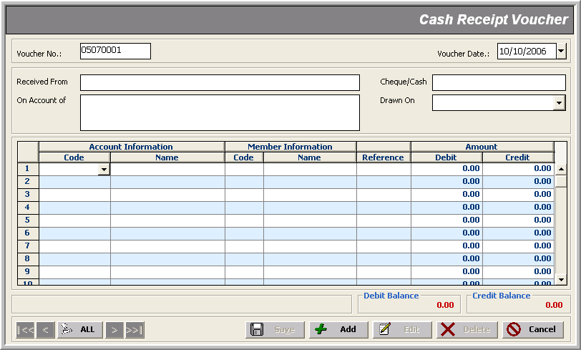
Credit Amount
* Voucher No
* GL Account
* Employee Info

* Voucher Date
* Received From Code
* On Account of
Debit Amount

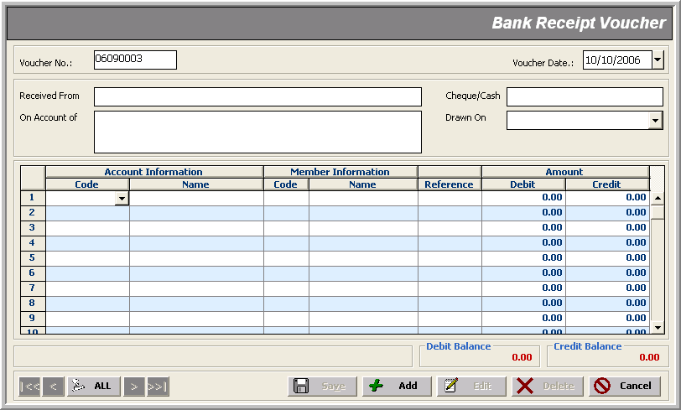
Credit Amount
* Voucher No
* GL Account
* Employee Info
* Voucher Date
* Received From Code
* On Account of
Debit Amount
* Check Info

Note that:
- Unequal ‘debit’ or ‘credit’ totals too raises an indication; though the user CAN proceed to save away such an entry by-passing this difference:
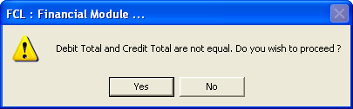

Cash/Bank Payment Voucher _______________________________________________________________________________
Use case: Recording Payments

Description
These forms are used to create Payment Vouchers with the following mandatory data entry:

- Voucher No (Auto generated in ‘yymmnnnn’ format)
- Voucher Date
- Paid To
- Check No (if receiving through check; mandatory in case of Bank Payment Voucher)
- Drawn On (the bank with which the check is drawn; mandatory in case of Bank Receipt Voucher)
- On Account of
- More than one journal entry against a GL Account and member

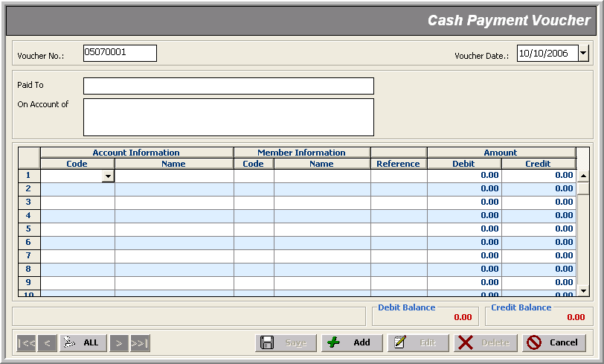
Credit Amount
* Voucher No
* GL Account
* Employee Info

* Voucher Date
* Paid To
* On Account of
Debit Amount

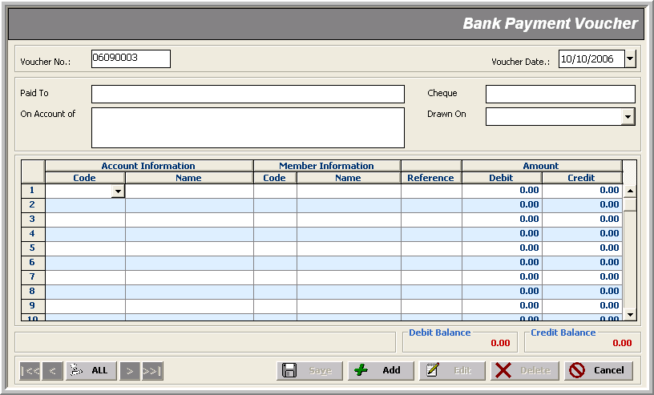
Credit Amount
* Voucher No
* GL Account
* Employee Info

* Voucher Date
* Paid To
* On Account of
Debit Amount
* Check Info

Note that:
- Unequal ‘debit’ or ‘credit’ totals too raises an indication; though the user CAN proceed to save away such an entry by-passing this difference:
Journal Voucher _______________________________________________________________________________
Use Case: Recording Adjustments to Receipts or Payments

Description
Adjustments to a receipt or a payment transaction is made through a Journal Voucher transaction; Here’s the mandatory data entry:

- Voucher No (Auto generated in ‘yymmnnnn’ format)
- Voucher Date
- Narration
- More than one journal entry against a GL Account and member

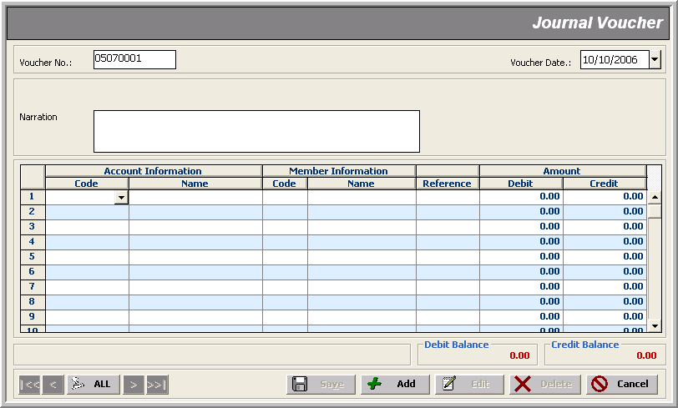
Credit Amount
* Voucher No
* GL Account
* Employee Info

* Voucher Date
* Narration
Debit Amount

Member’s Payment _______________________________________________________________________________
Use Case: Recording Payments to Members/Employees

Description
This form is used to create ‘payment vouchers for the Provident Fund Trust members’.

Here’s the mandatory data entry:

- Nature
- Voucher No (Auto generated in ‘yymmnnnn’ format)
- Voucher Date
- Member
- Credit Account: Bank Code, Check No, Drawn on (in case Nature is Bank Voucher)
- Credit Account: Cash Code (in case Nature is Cash Voucher)
- Credit Account: Credit Code (in case Nature is Journal Voucher)
- On Account Of (disabled for editing; relates to Type value in the journal entry)
- More than one journal entry against GL Accounts (debit & credit)

The only optional information is:
- Remarks

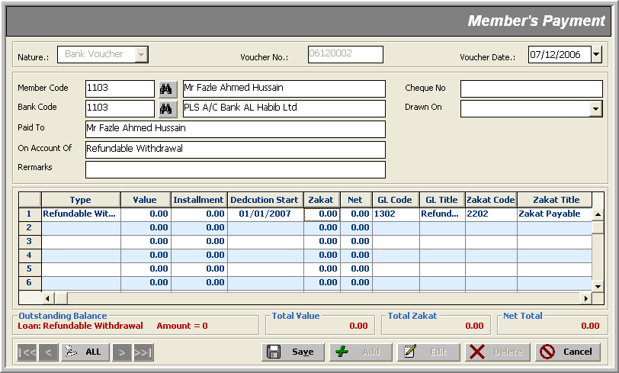
* Nature
* Voucher No
* Voucher Date
* Check Info
* Member
Bank /Cash/Credit Code
* Paid to
* On Account of From Info
Remarks
* Type of Account From Info
* Value
Installment Info
* GL Account
* Zakat Account
* Value
Net Amount

Note that:
- The system denies recording such payments for ‘any user’ if the selected member/employee has left; i.e. whose ‘Date Left is NOT blank’; obviously a member can’t pay when he has gone/left!
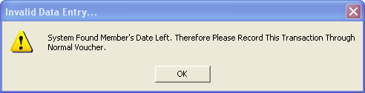
- The voucher’s header/master information changes with respect to its nature selected from the top left combo
- All header fields are mandatory except Remarks
- There’s a direct relation between a particular ‘Type’ selection and its corresponding amount ‘value’; negative ‘value’ input is never allowed:
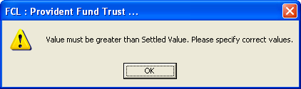
- Selecting a payment Type identifies whether or not ‘Installment’ and ‘Deduction Start’ date is editable:
Type Installment Deduction-Start
Permanent Withdrawal not editable not editable
Refundable Withdrawal editable editable
Accrued Markup on FP Loan not editable not editable
Markup on FP Loan not editable not editable
Others not editable not editable
(Currently, there’s no user specific difference of such behavior)
- Obviously, for Refundable Withdrawal payments, ‘Installment’ is mandatory:
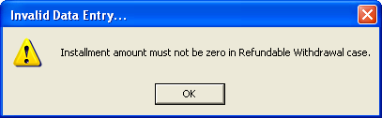
- Refundable Withdrawal payment is prohibited, if a member already have some balance on that account:
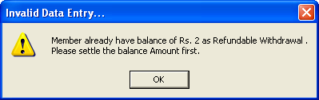
- Only the administrator can change ‘GL Zakat Code’ against a payment; so its columns are not visible and hence not editable to a normal user in the journal entry grid
- For Others payments, ‘GL Account Code’ is necessary to be provided; any user can do that; or else the system barks:
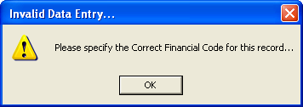
Member’s Settlement ___________________________________________________________________________
Use Case: Settling Member’s Payments

Description
This form is used to record member’s payments to settle vouchers created in Member’s Payment transactions.

Here’s the mandatory data entry:

- Nature
- Voucher No (Auto generated in ‘yymmnnnn’ format)
- Voucher Date
- Member
- Credit Account: Bank Code, Check No, Drawn on (in case Nature is Bank Voucher)
- Credit Account: Cash Code (in case Nature is Cash Voucher)
- Credit Account: Credit Code (in case Nature is Journal Voucher)
- On Account Of (disabled for editing; relates to Type value in the journal entry)
- More than one journal entry against a GL Account

The only optional information is:
- Remarks

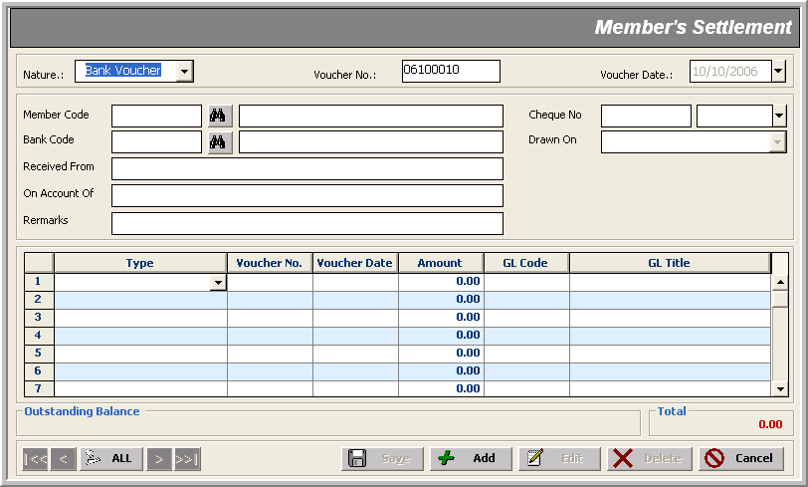
* Nature
* Voucher No
* Voucher Date
* Check Info
* Member
Bank /Cash/Credit Code
* Received From Info
* On Account of From Info
Remarks
* Type of Account From Info
Voucher Info
* Amount
* GL Account

Note that:
- The system denies recording such payments for ‘any user’ if the selected member/employee has left; i.e. whose ‘Date Left is NOT blank’; obviously a member can’t pay when he has gone/left!
- The voucher’s header/master information changes with respect to its nature selected from the top left combo
- All header fields are mandatory except Remarks
- There’s not tracking involved for the following settlement types; hence no voucher information is needed:
Accrued Markup on FP Loan
Markup on FP Loan
Others
- Obviously, no settlement is possible for an amount greater than the current ‘Outstanding Balance’:
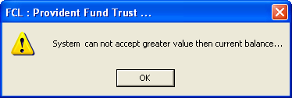
- For Others settlements, ‘GL Account Code’ is necessary to be provided; any user can do that; or else the system barks:

Reports
___________________________________________________________________________

The reports of Provident Fund Trust Financial module can be divided in three categories:

- Setup Reports
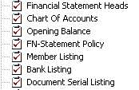
- Transaction Activities Reports
- Financial Statements Reports
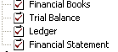
- Provident Fund Reports

- Zakat Deduction Reports

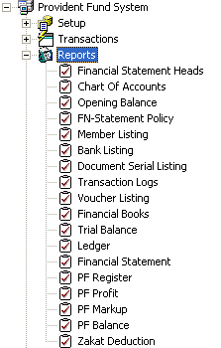 | 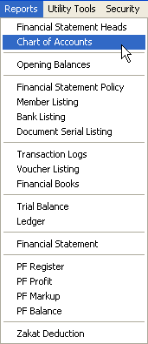

Utility Tools
_______________________________________________________________________________

Utility Tools cover periodic processes within a closing schedule life-cycle, such as:

- Auditing
- Posting
- Un-Posting
- JV Generation
- JV Deletion

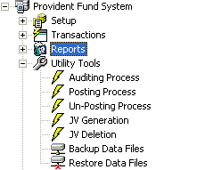 | 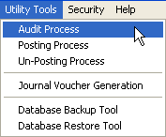

Auditing Process _______________________________________________________________________________

Description
Auditing Process is performed to trace out buggy transaction activities. It performs the following checks on all transactions made:

- Date mismatch
- Whether a process (say, Auditing, Posting or Un-Posting) is already running
- Checks for ‘un-balanced’ vouchers (i.e. where Dr and Cr Amount mismatch) and ‘Invalid Account Codes’
- scans through all the transactions and updates the status as ‘lock’ or ‘unlock’

Here’s how it proceeds:

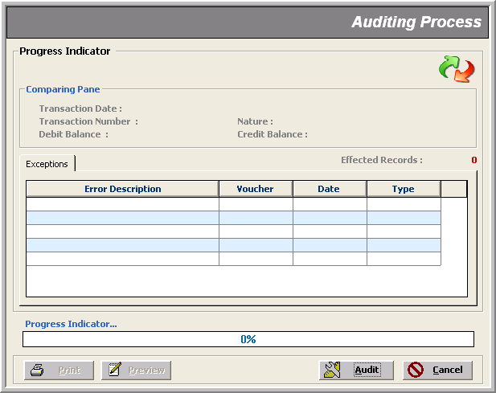
When is clicked, the following window appears indicating the start of Auditing Process.

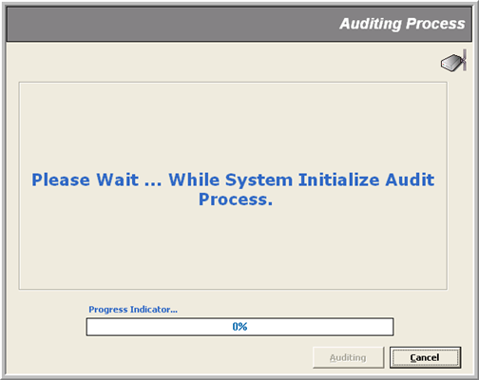

Next window shows that the Auditing Process is checking through transaction activities for possible bugs.
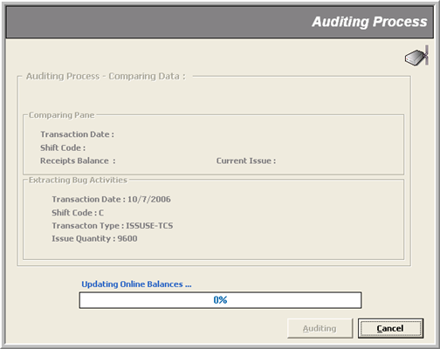
On successful check, a message box pops up saying ‘System did not found any Exception’.

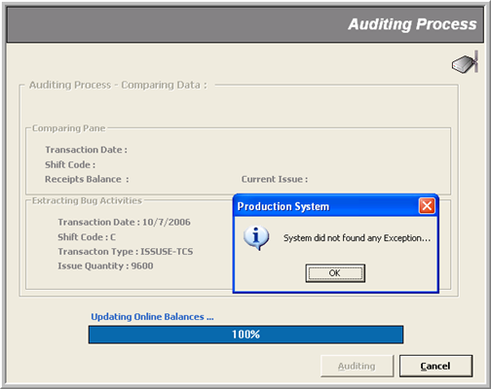s
Posting Process _______________________________________________________________________________

Description
Posting Process is performed to Post transactions in non-editable mode to tag them as ‘confirmed’ transactions. It performs the following tasks:

- Runs the ‘Auditing’ process up to date
- Locks all transactions for editing

Here’s how it proceeds:
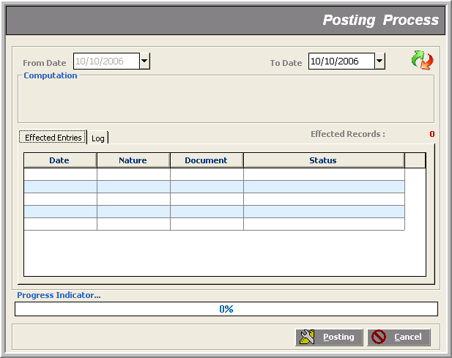

As Posting Process involves Auditing Process, so the system shows up the same screens as in the previous section; later, it initializes the Posting Process; and on finding un-posted data, a message box pops up asking for confirmation to go on. Next window shows the scan progress for un-posted transactions. Finally, a message box flags the end of process.

Un-Posting Process _______________________________________________________________________________

Description
Un-Posting Process performs the following jobs:

- Whether a process (say, Auditing, Posting or Un-Posting) is already running
- If some transaction types are checked AND their respective document no.’s range is provided; it ‘unlocks’ those documents for editing; other wise only first task is done

Note that:
- In Un-Posting Process, ’To Date’ is disabled meaning that the process ‘Un-Posts’ only those transactions that were recorded from ‘From Date’ until NOW
- This impacts the relevant reports in that now you can view only those transaction records that were made until the ‘From Date’ specified (all those ‘Posted’ to date)

Here’s how it proceeds:
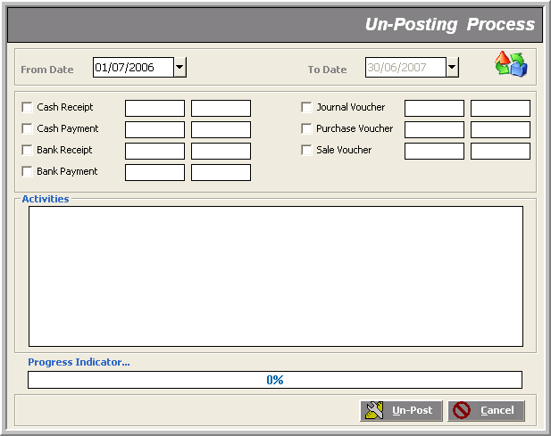

The process signals its successful finish giving a short description of the ‘Activities’ in the text area. If we had given document numbers’ range of a selected transaction nature, the process would have ‘unlocked’ those documents for editing

JV Generation ___________________________________________________________________________

Description
This process develops a key relation between FCL Payroll Module and FCL Provident Fund Trust Module. It gathers all kinds of necessary information about Provident Fund Trust members employed by FCL and generates a Journal Voucher worth as per their ‘last processed payroll’ of the specified type selected from the top left combo.
Secondly, it also leaves this generated JV reference in the member’s payroll transactions.

Note that:
- Now, here are the after-effects of this process:
1) Payroll ‘Un-Posting’ is banned for all transactions whose JV has been generated by FCL
Provident Fund Trust Module
- To run Payroll’s ‘Un-Posting’ process when this JV has been generated, the administrator must delete this JV with the help of JV Deletion Process which in effect reverts those Payroll transactions in their original mode; that is, it removes the flag that indicates that the JV has already been created against the transaction
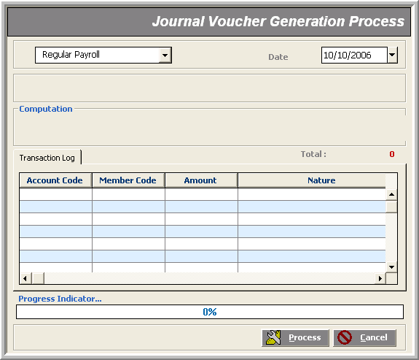
JV Deletion ___________________________________________________________________________

Description
This process deletes the Journal Vouchers generated through JV Generation Process mentioned before and updates the payroll transactions of the specified type by removing the JV reference therein.

Note that:
- Now, here are the after-effects of this process:
1) Payroll ‘Un-Posting’ is allowed for all transactions whose JV has been deleted
